bida25-462
WEB & MULTIMEDIA DEVELOPMENT Assignment
Sesame Bahumi Hunyepa
2026

PART A- WEBSITE PLANNING & DOCUMENTATION
- Website Specification
Website Objective
The objective of the LUXORA website is to create a stylish online clothing store that allows users to view and explore fashion products from different categories, including swimwear, shapewear, sleepwear, and sets. The website is designed to present the LUXORA brand as a modern, elegant, and luxury-inspired fashion business.

The main purpose of the website is to promote LUXORA’s products, attract potential customers, improve brand visibility, and provide users with easy access to products information such as product names, prices, images, and categories. The homepage includes a “NEW SUMMER COLLECTION” hero section, a “Show Now” button, category cars, and a promotional pop-up offering users 10% off when they sign up with their emails.

Business Goals
The business goals of the LUXORA website are:
- To promote LUXORA as a fashionable and luxury-oriented clothing brand.
- To display products clearly using images, prices, and categories.
- To encourage users to browse product categories such as Swimwear, Shapewear, Sets, and Sleepwear.
- To increase customer engagement through a newsletter sign-up form and promotional pop-up.
- To create a professional online presence that can later be developed into a full e-commerce website.
- To make navigation simple so users can move between product pages easily.
Target Audience
The target audience for the LUXORA website is mainly fashion-conscious customers interested in stylist clothing, swimwear, shapewear, and matching sets.
Category | Description
Age group | Mainly young adults and adults, approximately 18-40 years old.
Gender | Primarily women, but the brand can also appeal to anyone interested in stylist fashion.
Interests | Fashion, luxury clothing, swimwear, shapewear, sleepwear, online shopping.
TECHNICAL APTITUDE | Basic to moderate. Users should be able to browse pages, click links, use a search bar, and submit simple forms.
Devices used | Smartphones, tablets, laptops, and desktop computers.

Type of Website
LUXORA is a business/ e-commerce product catalogue website. At this stage, the website mainly works as an online product showcase rather than a fully functioning payment-based online store. It displays products by category and allows users to search for products, view product images, and see prices.
The website includes product categories, navigation links, promotional content, a newsletter form, and product images. This matches the assignment requirement that the website should have multiple interlinked pages, good use of images, page uniformity, and HTML, CSS, Bootstrap, and JavaScript functional.

- Information Design & Taxonomy
The information architecture of the LUXORA website is organized around product categories. This makes it easy for users to find products according to the type of clothing they are interested in.
Page | Purpose
index.html | Homepage introducing the LUXORA brand, summer collection, category links, and promotional pop-up.
swimwear.html | Displays swimwear products such as bikinis, one pieces, sarongs, and kaftans.
shapewear.html | Displays shapewear products such as bodysuits, sculpting shorts, and body-shaping items.
sleepwear.html | Displays sleepwear products such as robes, pajama sets, and babydoll dresses.
sets.html | Displays clothing sets such as hoodies, joggers, tanks, boxers, and matching pieces.
contact.html | Allows users to contact the business.
about.html | Provides information about the LUXORA brand.
search.html | Displays product search results from across the website.

The website’s site map illustrates the structure and connection between pages:

LUXORA CLOTHING STORE (index.html)
Contact Us (contact.html)
SWIMWEAR (swimwear.html)
SHAPEWEAR (shapewear.html)
SLEEPWEAR (sleepwear.html)
SETS (sets.html)
About Us
(about.html)
Search
(search.html)

- Technical Brief
The LUXORA website was developed using front-end web technologies suitable for a small business fashion website.
Technology/ Tool | Purpose
HTML5 | Used to create the structure of the website pages, including headings, sections, forms, navigation, images, and product cards.
CSS3 | Used to design the layout, colors, typography, product grids, hover effects, navbar, footer, and responsive styling.
Bootstrap 5 | Used to support responsive design and ready-made styling utilities.
JavaScript | Used for interactive features such as the promotional pop-up, product preview, search bar, and button interactions.
VS Code | Used as the main code editor for writing HTML, CSS, and JavaScript.
GitHub | Used to store the website files in a repository.
GitHub Pages | Used to publish the website online.
Image editing tools | Used to prepare product images, banners, and promotional visuals.
Web browsers | Used for testing, including Chrome, Firefox, Microsoft Edge, and Safari.

The website uses an external stylesheet called style.css, Bootstrap CSS, and JavaScript files such as search.js. The homepage also includes JavaScript for the promotional pop-up, allowing the pop-up to chow only once by using localStorage.

- Page Template Design
HOMEPAGE
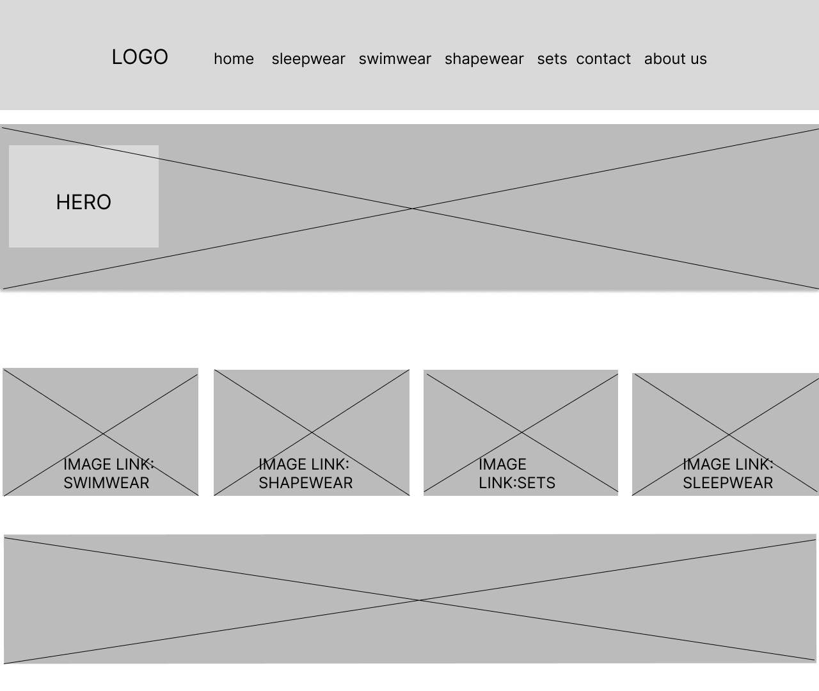

SWIMWEAR

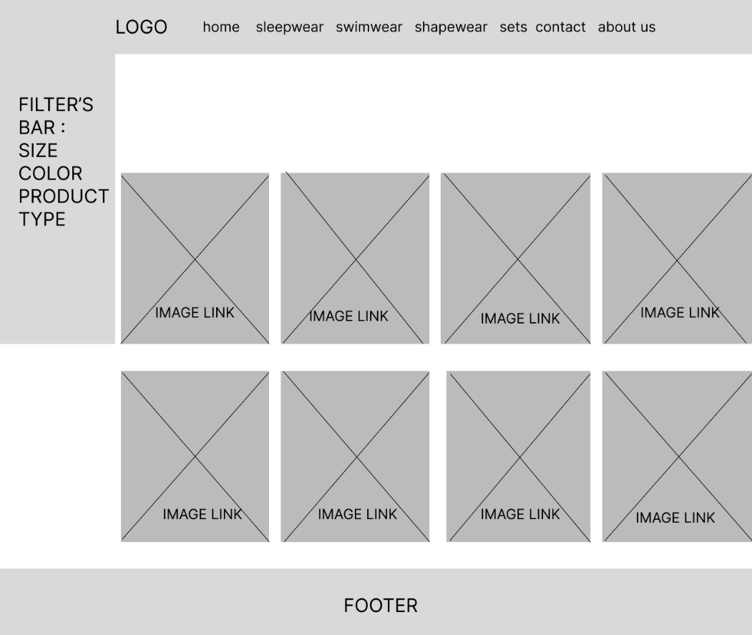
SLEEPWEAR
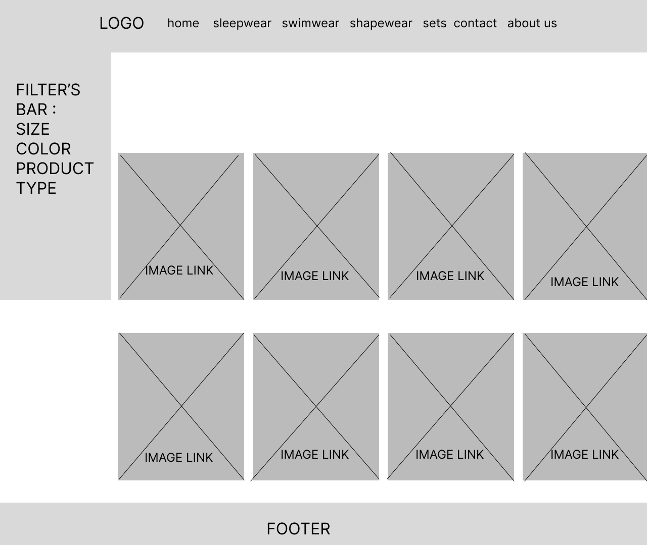
SHAPEWEAR
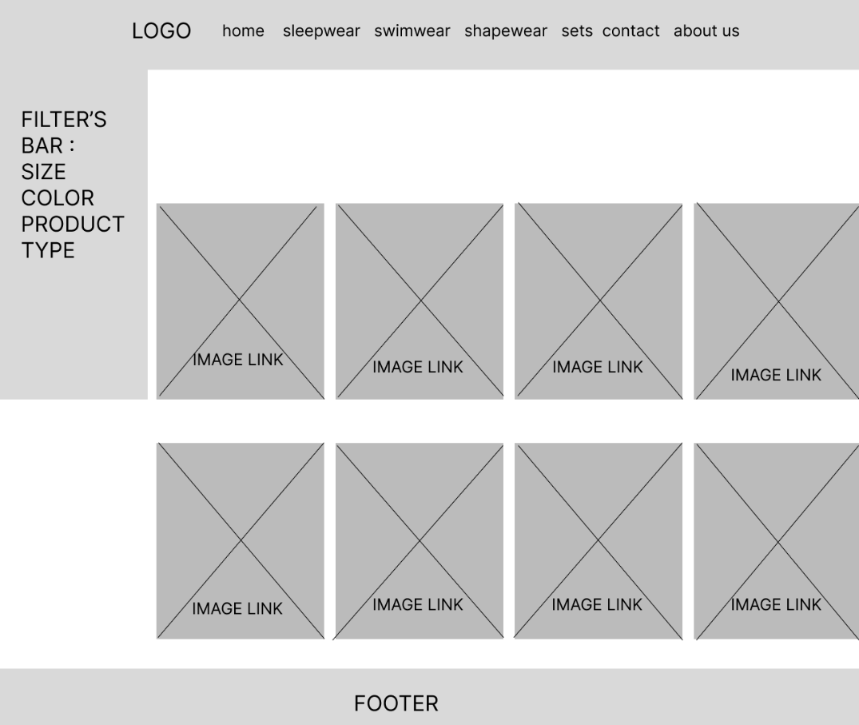
SETS
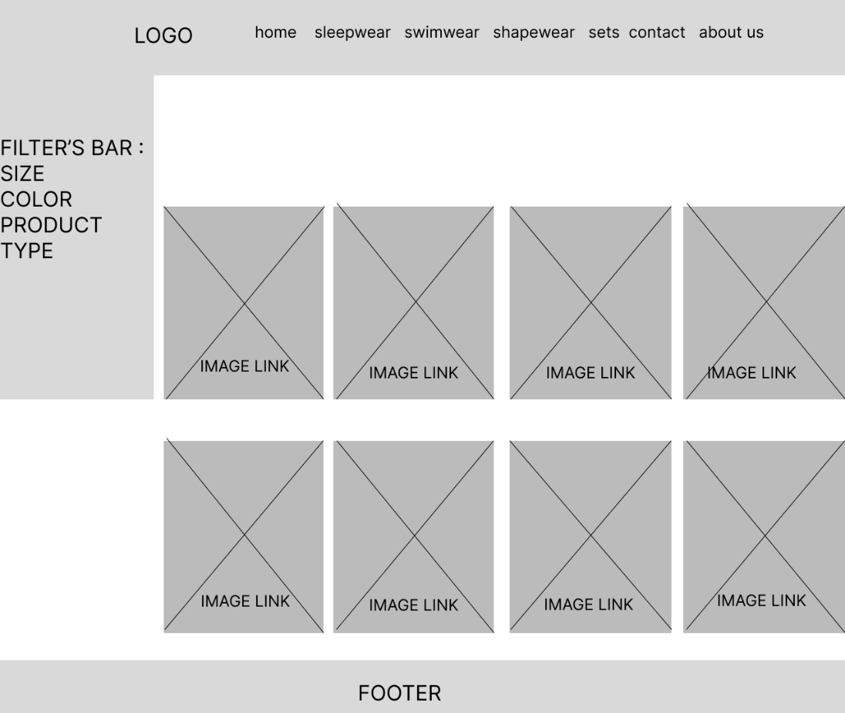
CONTACT US
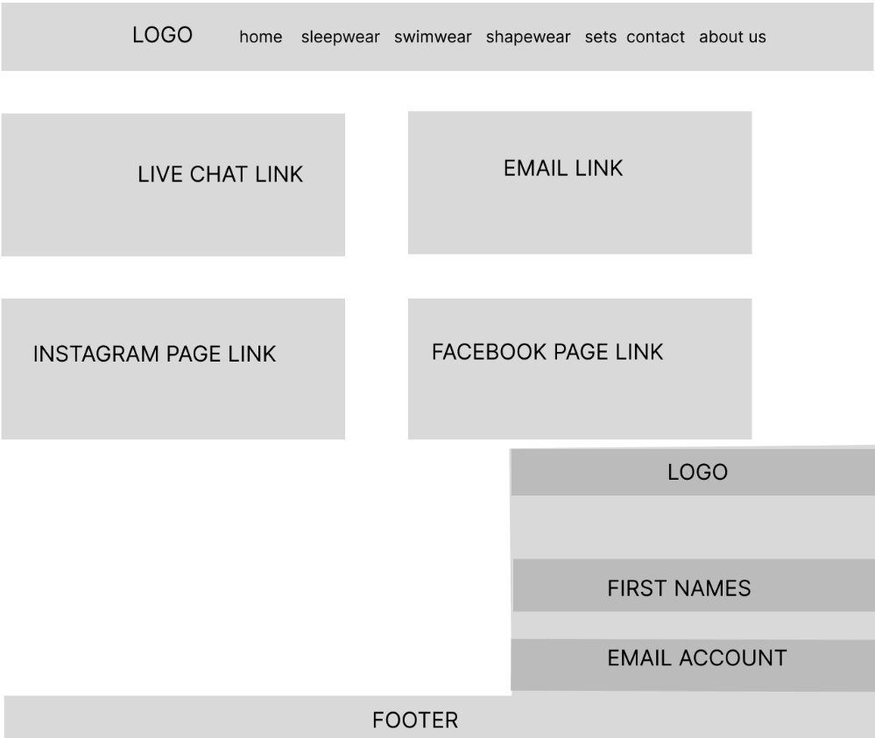

ABOUT US
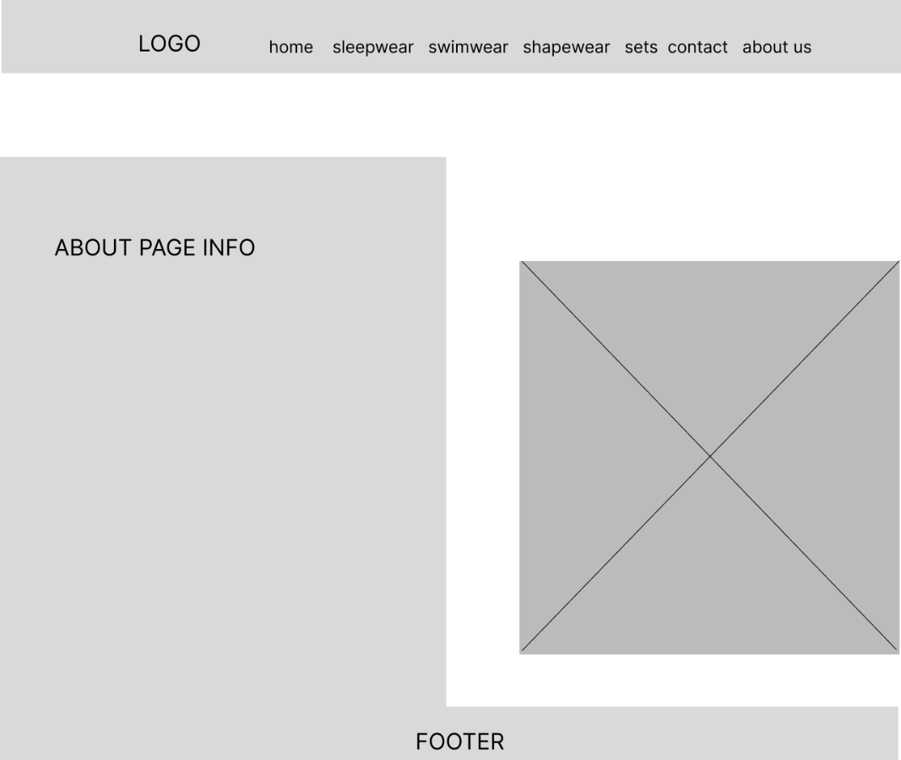

CLOTHING PAGE
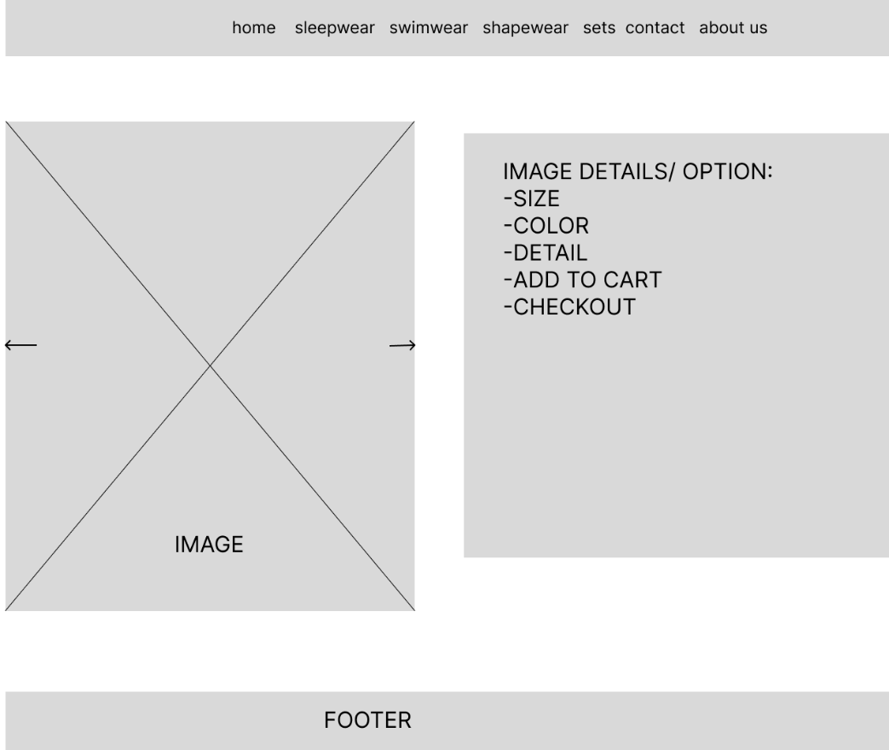

SIGNUP FORM
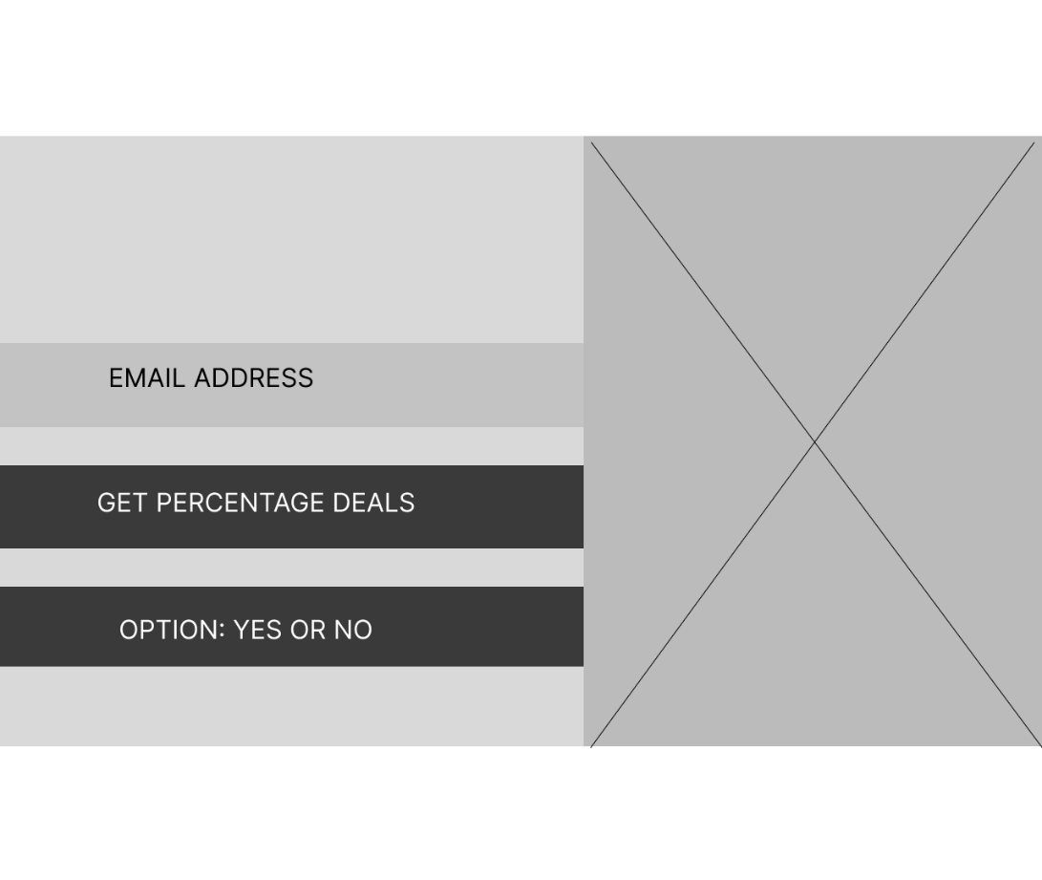
Homepage Template
The homepage includes:
- A fixed LUXORA navbar.
- A promotional pop-up offering 10 % off.
- A hero section advertising the new summer collection.
- A “Shop Now” button linking to the swimwear page.
- Product category cards for Swimwear, Shapewear, Sets, and Sleepwear.
- A brand statement.
- A footer with Help, Newsletter, and More sections.

Product Page Template
Each product page uses:
- A page heading, for example “Sleepwear” or “Swimwear”.
- A grid layout for products.
- Product cards containing:
- Product image
- Brand name
- Product name
- Price
- Hover image effects.
- Product preview section.
- Add to cart and checkout buttons.
- Footer and newsletter area.

The page template was chosen because it supports easy browsing and gives products enough visual space. The use of a grid layout makes the product pages look organized and professional. The fixed navbar improves navigation because users can access the main pages at any time. The white background and simple layout support a luxury fashion style.

- HTML Structure
The structural layer of the LUXORA website was built using HTML5. HTML5 defines the main layout and content areas of the website. It organizes the page into meaningful sections such as the header, navigation bar, hero section category section, forms, and footer.

- Page Setup
The page begins with the HTML5 document structure. The <head> section contains the character set, viewport settings for responsiveness, page tittle, Bootstrap link, and the external CSS file. This helps the website display correctly on different devices.
<!DOCTYPE html>
<html lang="en">
<head>
<meta charset="UTF-8">
<meta name="viewport" content="width=device-width, initial-scale=1.0">
<title>LUXORA CLOTHING STORE</title>
<!--Bootstrap CSS-->
<link href="https://cdn.jsdelivr.net/npm/bootstrap@5.3.0/dist/css/bootstrap.min.css"
rel="stylesheet">
<!--Custom CSS-->
<link rel="stylesheet" href="styles.css">
</head>

- Header and Navigation
The <header> contains the LUXORA logo and the main navigation menu. The <nav> element is used for links to the main pages, allowing users to move easily between Home, Sleepwear, Swimwear, Shapewear, Sets, Contact, and About Us.
<!-- NAVBAR -->
<header class="luxora-navbar">
<div class="nav-logo">LUXORA</div>

<nav class="nav-links">
<nav class="main-nav"></nav>
<a href="index.html">Home</a>

<!-- Sleepwear -->
<nav class="nav-item has-mega">
<a href="sleepwear.html">Sleepwear</a>
</nav>

<!-- Swimwear -->
<nav class="nav-item has-mega">
<a href="swimwear.html">Swimwear</a>
</nav>

<!-- Shapewear -->
<nav class="nav-item has-mega">
<a href="shapewear.html">Shapewear</a>
</nav>

<!-- Sets -->
<nav class="nav-item has-mega">
<a href="sets.html">Sets</a>

<div class="mega-menu">
<div class="mega-content">

<div class="mega-column">
<a href="/sets/sleep-sets">Sleep Sets</a>
<a href="/sets/swim-sets">Swim Sets</a>
</div>

</div>
</div>
</nav>
<a href="contact.html">Contact</a>
<a href="about.html">About Us</a>

<form class="site-search" id="siteSearchForm">
<input
type="text"
id="siteSearchInput"
placeholder="Search products..."
>
<button type="submit">Search</button>
</form>
</nav>

</header>

- Hero Section
The hero section introduces the main promotion of the website. It uses headings, paragraphs, an image, and a button linking to the swimwear page. The section acts as the main visual introduction to the LUXORA brand.
<section class="hero">
<section class="swimwear">
<div class="bg-blur">
<img src="img6.png" alt="swimwear">
</div>
</section>
<div class="hero-text">
<h2>NEW SUMMER</h2>
<h1>COLLECTION</h1>
<p>CLASSIC SWIMWEAR OUT NOW!</p>
<p>*LIMITED EDITION*</p>
<a href="swimwear.html" class="category-link">
<button class="hero-btn">Shop Now</button>
</a>
</form>
</div>
</section>

- Category Section
The category section groups the main product areas of the website. Each category card uses an image and a link, making it easy for users to access Swimwear, Shapewear, Sets, and Sleepwear.

<section class="categories">
<h2>SHOP CATEGORIES</h2>

<div class="cat-grid">
<div class="cat-card">
<a href="swimwear.html" class="category-link">
<img src="swimwear.png" alt="NEW SWIMWEAR ARRIVALS">
<p>NEW SWIMWEAR ARRIVALS</p>
</a>
</div>

<div class="cat-card">
<a href="shapewear.html" class="category-link">
<img src="shapewear.png" alt="Shapewear">
<p>SHAPEWEAR</p>
</a>
</div>

<div class="cat-card">
<a href="sets.html" class="category-link">
<img src="sets.png" alt="Sets">
<P>SETS</P>
</a>
</div>

<div class="cat-card">
<a href="sleepwear.html" class="category-link">
<img src="sleepwear.png" alt="Sleepwear">
<P>SLEEPWEAR</P>
</a>
</div>
</div>
</section>

- Forms
Forms are used for user interaction. The homepage includes a pop-up email form and the footer contains a newsletter form. The required attribute is used to make sure the user enters an email address before submitting.
<!-- FULLSCREEN POPUP OVERLAY -->
<div id="luxora-popup" class="popup-overlay">

<div class="popup-box split-popup">

<!-- CLOSE BUTTON -->
<button class="popup-close" id="popupClose">×</button>

<!-- LEFT SIDE: SIGN UP -->
<div class="popup-left">
<h2>Want 10% Off?</h2>
<p>Sign up for email and enjoy 10% off your first full-priced purchase.</p>

<form class="popup-form">
<input type="email" placeholder="Email Address" required>
<button type="submit" class="popup-btn primary">
GET 10% OFF NOW
</button>
<button type="button" class="popup-btn secondary" id="popupDecline">
NO, I’LL PAY FULL PRICE
</button>
</form>

<small>
By submitting your email, you agree to receive marketing emails from LUXORA.
</small>
</div>

<!-- RIGHT SIDE: IMAGE -->
<div class="popup-right">
<!-- You insert your image here -->
<img src="swim.png" alt="LUXORA Campaign">
</div>

</div>

</div>
Newsletter form:

<section class="luxora-footer">
<div class="footer-content">

<div class="footer-column">
<h4>Help</h4>
<a href="contact.html" class="contact-page">Contact Us</a>
</div>

<div class="footer-column newsletter">
<h4>Stay in the know</h4>
<p>Be the first to discover new drops, special offers and all things LUXORA.</p>

<form class="newsletter-form">
<input type="email" placeholder="Your email" required>
<button type="submit">→</button>
</form>

<small>
By submitting your email you agree to receive marketing messages from LUXORA.
</small>
</div>

<div class="footer-column">
<h4>More</h4>
<a href="about.html" class="about-page">About Us</a>
</div>

</div>
</section>

- Footer
The footer provides extra navigation and support information. It includes Contact Us, About Us, newsletter signup, and copyright information.

<section class="luxora-footer">
<div class="footer-content">

<div class="footer-column">
<h4>Help</h4>
<a href="contact.html" class="contact-page">Contact Us</a>
</div>

<div class="footer-column newsletter">
<h4>Stay in the know</h4>
<p>Be the first to discover new drops, special offers and all things LUXORA.</p>

<form class="newsletter-form">
<input type="email" placeholder="Your email" required>
<button type="submit">→</button>
</form>

<small>
By submitting your email you agree to receive marketing messages from LUXORA.
</small>
</div>

<div class="footer-column">
<h4>More</h4>
<a href="about.html" class="about-page">About Us</a>
</div>

</div>
</section>

<footer>
<p>&copy;2026 LUXORA CLOTHING STORE</p>
</footer>

Behavioral Layer- JavaScript
The behavioral layer of the LUXORA website was created using JavaScript. JavaScript adds interactivity to the website, allowing users to interact with pop-ups, search products, and use dynamic page features.
- Promotional Pop-up
JavaScript controls the discount pop-up on the homepage. When the website loads, the pop-ups appears. The user can close it or decline the offer. The code also uses localStorage so the pop-up does not keep appearing every time after it has been closed.
const popup = document.getElementById("luxora-popup")
const signupBar = document.getElementById("signup-bar")
const closePopupBtn = document.getElementById("popupClose")
const openPopupBtn = document.getElementById("openPopup")
const closeBarBtn = document.getElementById("closeSignupBar")

// Show popup only once
window.onload = function () {
if (!localStorage.getItem("luxoraPopupClosed")) {
popup.style.display = "flex"
}
}

// X on popup → show bottom bar
closePopupBtn.addEventListener("click", function () {
popup.style.display = "none"
signupBar.style.display = "block"
localStorage.setItem("luxoraPopupClosed", "true")
})

- Search Functionality
The search bar uses JavaScript to take the user’s search input and redirect them to the search results page. This allows users to search for products from any page of the website.
const searchForm = document.getElementById("siteSearchForm");
const searchInput = document.getElementById("siteSearchInput");

if (searchForm && searchInput) {
searchForm.addEventListener("submit", function(event) {
event.preventDefault();

const searchValue = searchInput.value.trim();

if (searchValue !== "") {
window.location.href = "search.html?q=" + encodeURIComponent(searchValue);
}
})
}

- Search Results Display
JavaScript also filters the product list and displays matching results on the search page. The results show product image, brand, name, category, and price, making the search feature useful for users.

const filteredProducts = products.filter(product => {
const searchText = `
${product.name}
${product.category}
${product.brand}
${product.keywords}
${product.price}
`.toLowerCase();

return searchText.includes(query.toLowerCase());
})

- Product Preview
On the product pages, JavaScript allows users to click a product card and view a larger preview. The preview displays the selected product’s image, brand, name, price, and description.

productCards.forEach(card => {
card.addEventListener("click", function () {
const image = card.querySelector(".main-img") || card.querySelector("img")

previewImg.src = image.src
previewBrand.textContent = card.dataset.brand
previewName.textContent = card.dataset.name
previewPrice.textContent = card.dataset.price
previewDescription.textContent = card.dataset.description

preview.classList.add("active")
productsSection.classList.add("preview-open")

- Add to Cart and Checkout Buttons
JavaScript is used to create simple feedback when the user clicks the Add to Cart or Checkout buttons. At this stage, the buttons show alert messages to confirm the action.

addCartBtn.addEventListener("click", function () {
alert("Added to cart")
})

checkoutBtn.addEventListener("click", function () {
alert("Checked out")
})

- Quality Assurance
Quality assurance testing was carried out to check that the LUXORA website works correctly on different pages, browsers, and screen sizes. The main areas tested were navigation, product display, search functionality, forms, responsiveness, and page consistency.

Test Area | Page Tested | Expected Result
Navigation Links | All pages | Navbar links should open the correct pages
Product display | Sleepwear, Swimwear, Shapewear, Sets | Product images, names, brands, and prices should display correctly
Search function | Search page | Searching a product should display matching result
Forms | Homepage/ newsletter/ contact | Required input fields should work correctly
Mobile view | iPhone SE view | Websites should fit phone screen without horizontal overflow
Tablet view | iPad Mini view | Product grid should adjust neatly
Desktop view | Laptop/Desktop | Website should display full layout correctly
Browser compatibility | Chrome, Edge/Firefox | Website should display consistently across browsers

Testing showed that the website functions correctly across the main pages. Some layout issues were found during mobile testing, such as navbar overflow and image sizing problems. These were corrected using responsive CSS so that the website fits phone, tables, and desktop screen sizes.

- Homepage in Mozilla FireFox
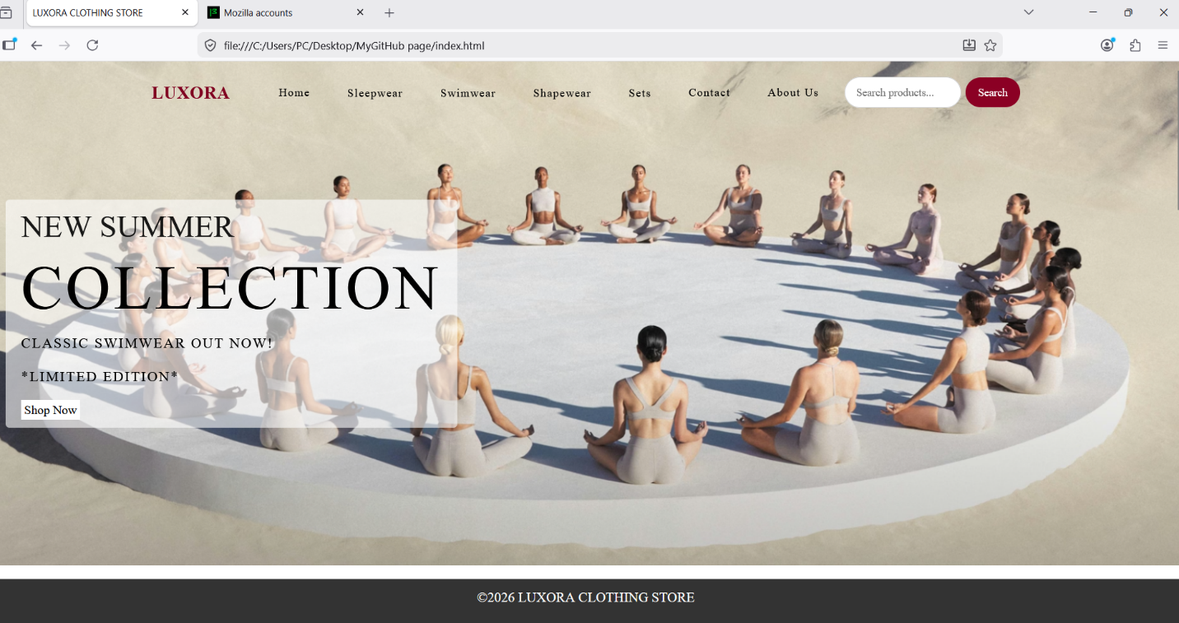
- Product page on desktop/laptop
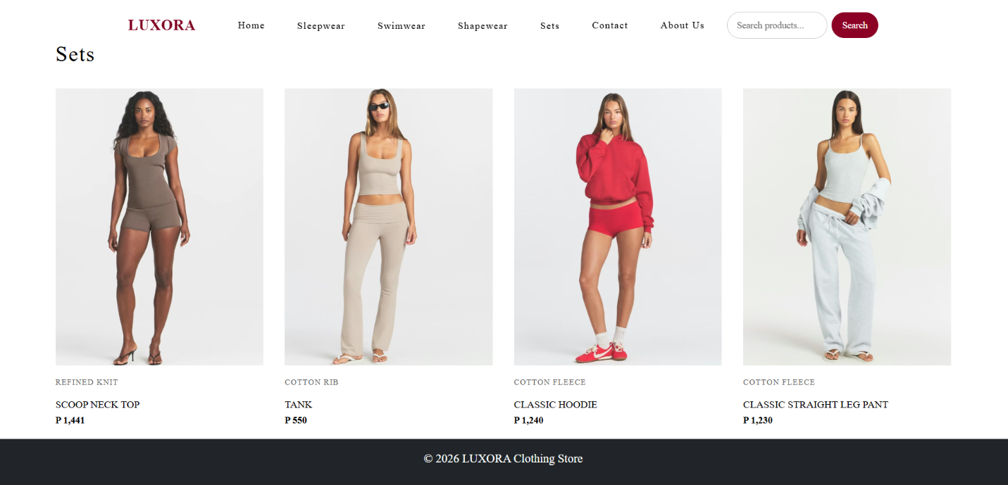
- Mobile test screenshot
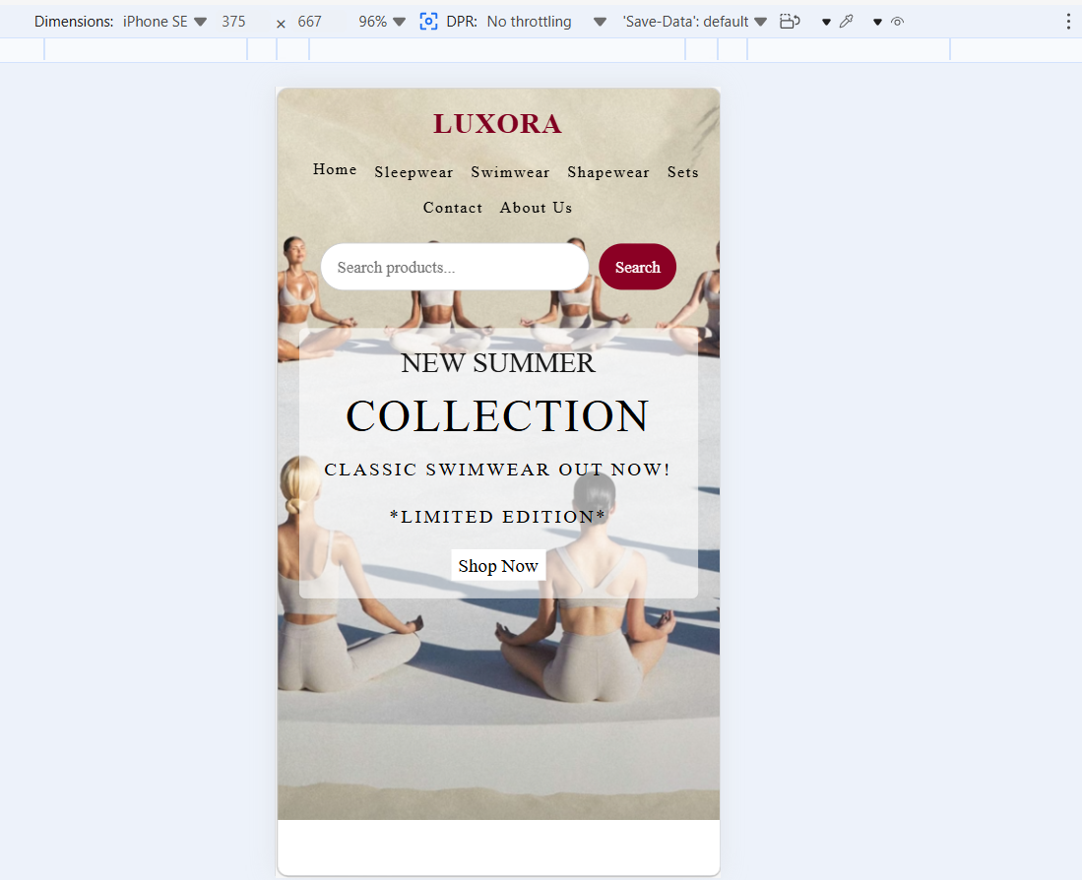
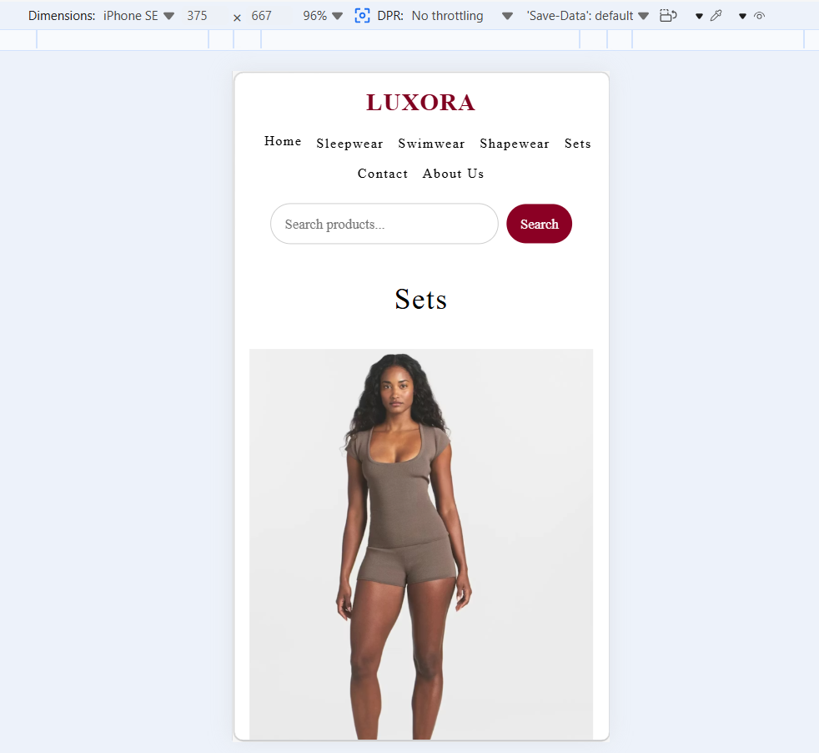
- Tablet test screenshot
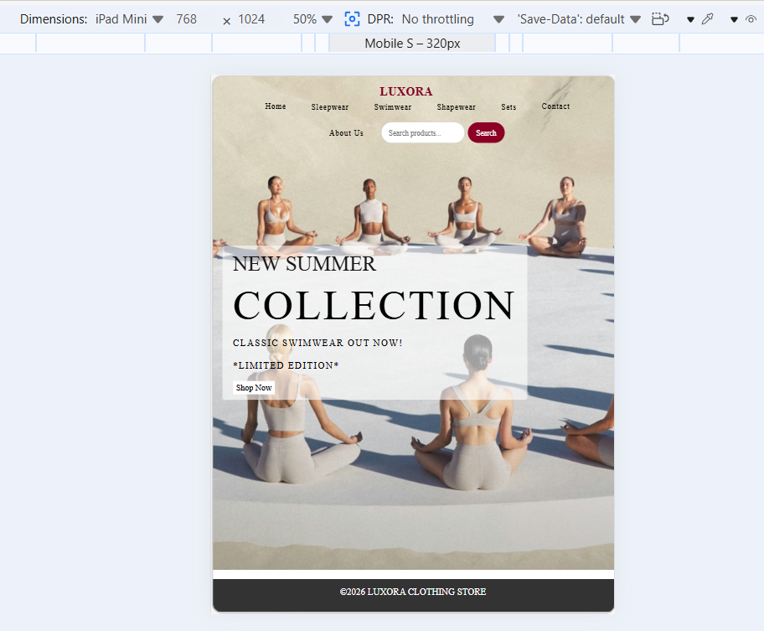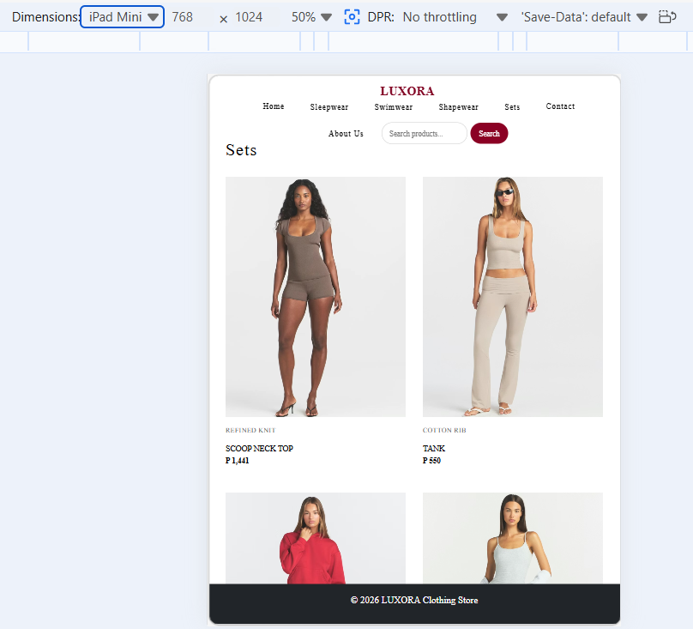
- Search results screenshot

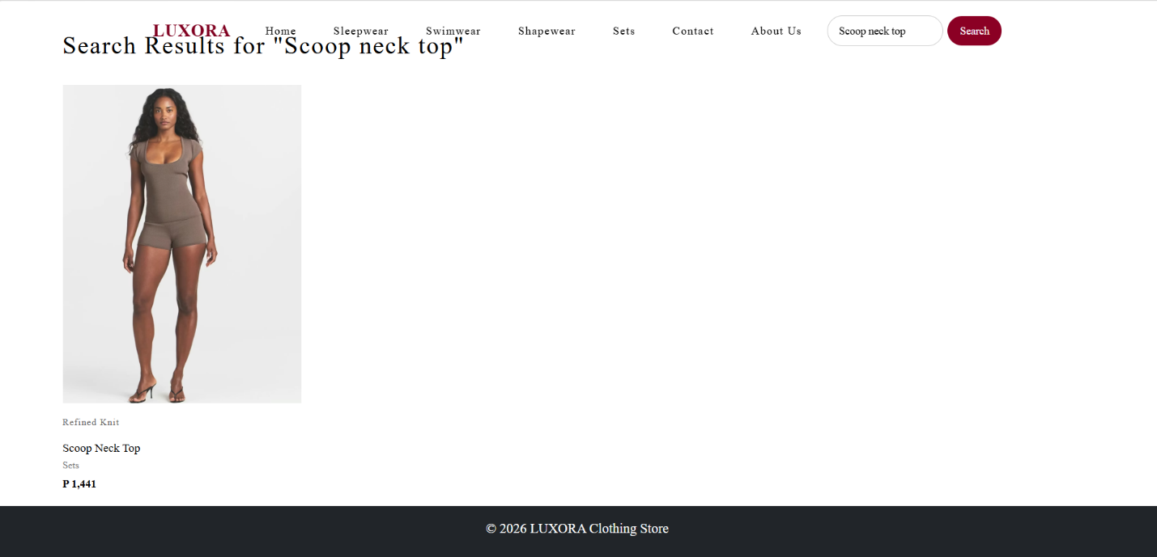

- Publishing & Promotions
The LUXORA website will be hosted using GitHub Pages. All website files, including HTML, CSS, JavaScript, and image folders, are uploaded to a GitHub repository. GitHub Pages are used because it allows the website to be published online and accessed through a live web link.

The website was developed using VS Code and the uploaded to GitHub using Git commands. The main file is index.html, which acts as the homepage of the website. Examples of Git commands used:

git init
git add .
git commit -m “Added LUXORA website files”
git branch -M main
git remote add origin https://github.com/Sesame702/sesame702.git
git push -u origin main

After uploading the files, GitHub Pages were enables from the repository settings by selecting the main branch as the publishing source.
Repository Link:
https://github.com/Sesame702/my-github-page

Website Link:
https://Sesame702.github.io/Sesame702
For promotion, the website ca be shared through social media platforms such as Instagram, TikTok, and Facebook. The newsletter sign-up and discount pop-up can also help promote new products, special offers, and future LUXORA collections.

- Future Developments/ Recommendations
In the future, the LUXORA website can be improved by adding more advanced e-commerce features. The current website displays products, prices, categories, a search function, and basic buttons, but it can be developed further into a complete online shopping platform.

Recommended future improvements include:
Future Improvement | Reason
Full shopping cart | Allows customers to add multiple products and view total cost
Online payment system | Allows real checkout and payment
Product filters | Helps users filter by size, price, category, and color
Customer accounts | Allows users to save details, orders, and wish lists
Product detail pages | Gives each product more images, size guide, and description
Better mobile menu | Improves navigation on phone screens
Customer reviews | Helps users make better buying decisions
Image optimization | Makes the website load faster

Overall, LUXORA can be improved by turning it from a product catalogue into a fully functional e-commerce website with cart, payment, filtering, and customer account features.

